Verifying Excluded Parties
Job Aid
This job aid guides you on how to search for and review SAM.gov website to determine if their agency can contract with a particular entity.
☐ | Step 1: On the homepage of SAM.gov, click “Search Records” to find either existing entity registration records or exclusion records.  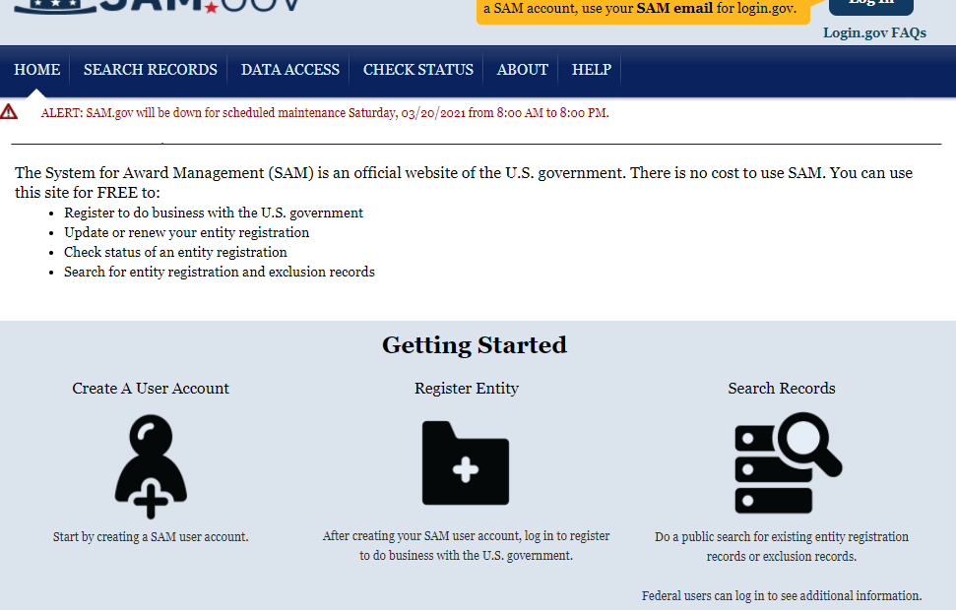
☐ | Step 2: On the search, you can search by (a) Entity Name, (b) DUNS Number, or (c) CAGE Code  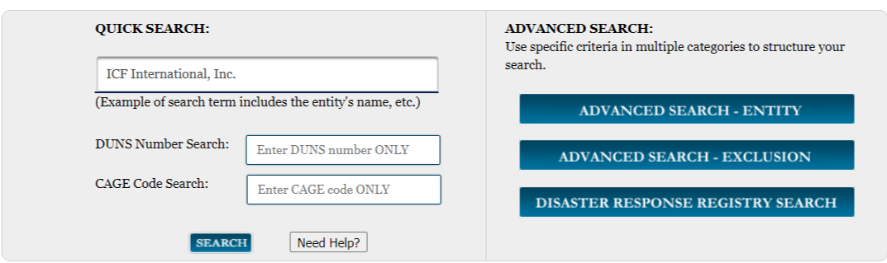
☐ | Step 3: Once located, the corresponding entity should appear with three sections to review.  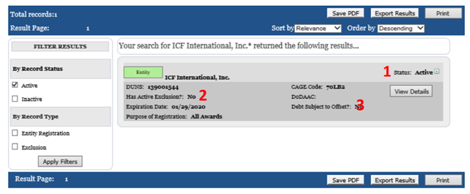  - The individual or entity has a status listed as “Active” which means they are registered to receive federal funding. Move onto #2.  - “Inactive”, the individual may need to register to receive federal funding and you cannot contract with them.  - Is there an active exclusion? If no, move to #3  - If yes, you cannot contract with them.  - Debt subject to offer: If “no”, you can contract with this entity.  - If the section has “yes” you can click the “view details” box to review exclusion information. It is important to note: if the details page indicates they have been suspended or debarred, you cannot contract with them. Any other reason for exclusion may result in asking the entity to contact SAM before contracting.

