Zoom VDI Plug-In Installation Instructions for Windows
If logged into VDI, please disconnect your existing session before proceeding with the installation.
- Download the latest ZoomCitrixHDXMediaPlugin.msi from https://www.ojp.gov/byod
- Navigate to downloads and double-click file to launch installation
- Select Next at Welcome
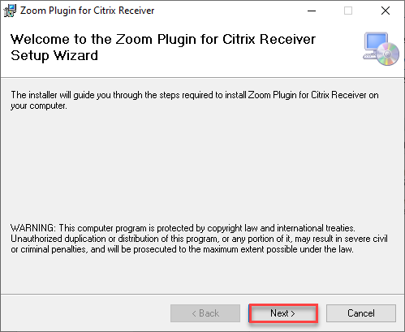
- Select Next to install to default location
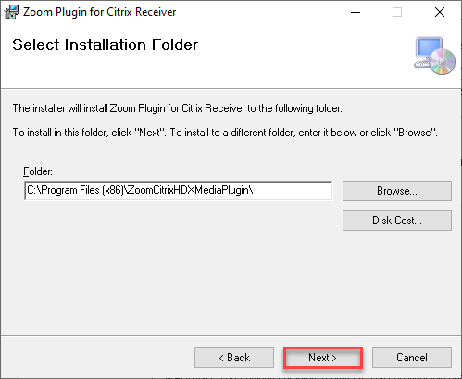
- Select Next to start the installation
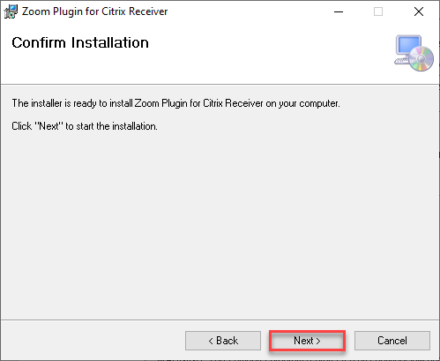
- Select Close at completion
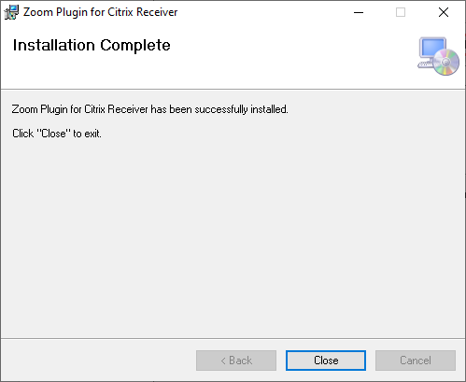

Verification
- Launch VDI desktop
- Start the Zoom application
- Confirm through Settings > Statistics > VDI that the VDI Plugin Status is “Connected”
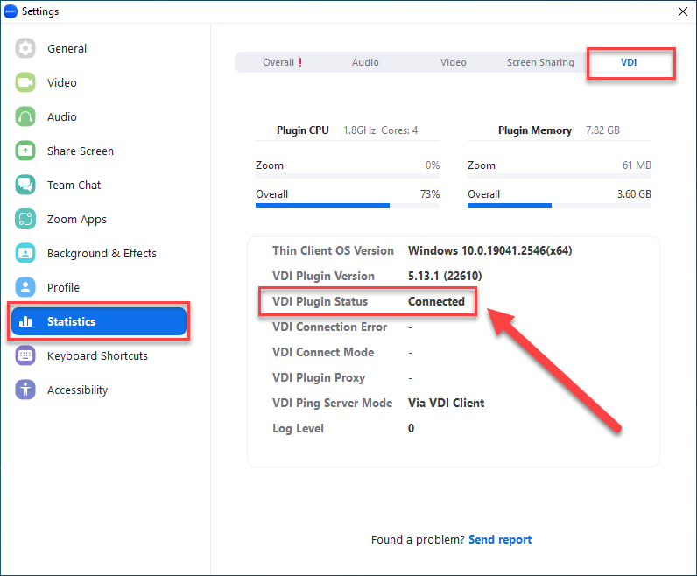
Congratulations! You will now have an optimal Zoom meeting experience!

